Kitasoo/Xai’xais Drone Application

Contact Information
Pilot’s Name:  Pilot UAV certificate Number:  Affiliations/Institution:  Others involved (include position): | Telephone:  Email:
Is your UAV registered with Transport Canada?
Transport Canada registration number:
Date(s) of proposed flights:
Location(s) of proposed flights:

Purpose (recreation, research, other)

Expected outcomes, beneﬁts, and impacts

Outcomes

Benefits

The applicant wishes to use the drone footage for their benefit in the following ways:

The activities would benefit the Kitasoo/Xai’xais Nation and/or territory in the following ways:

Impacts (e.g., environmental, financial, social, and cultural)

The activities pose the following impacts to the Kitasoo/Xai’xais Nation and/or territory:

Measures that would be taken to minimize these are:

Data Sharing
- I am willing to provide the Kitasoo/Xai’Xais Stewardship Authority with a copy of UAV footage and/or data collected.

Applicant Signature

________________________________________ ___________________________________
Applicant Signature Date (mm/dd/yyyy)

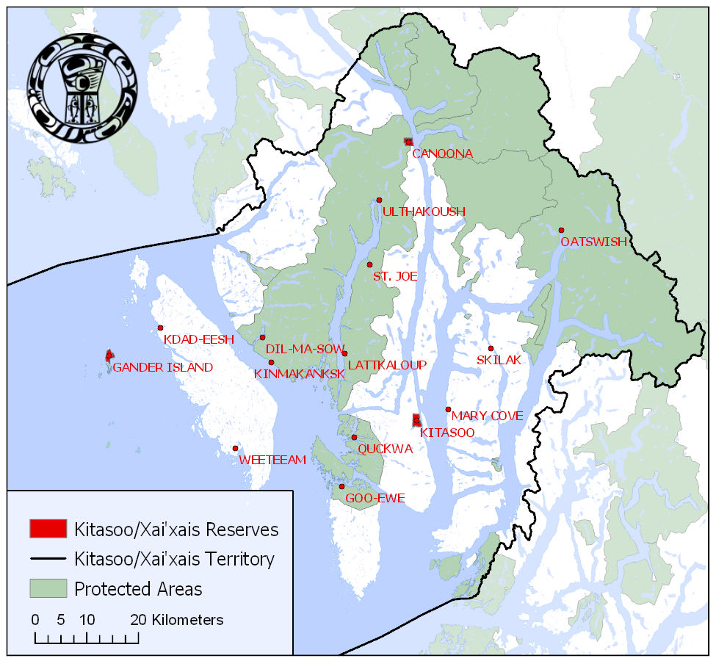
SCHEDULE A
Kitasoo/Xai’Xais Territory

