Kitasoo/Xai’xais Research Proposal

The Kitasoo/Xai’xais First Nation values the potential contributions of research related to the Kitasoo/Xai’xais Nation and territory (Appendix A). Projects that are most likely to be approved by the Nation are community-engaged, invite Nation participation at all stages of the research (i.e., from conception to dissemination), investigate questions driven by the Nation, and demonstrate clear benefit or application to the Nation. We seek research partnerships and relationships that are based in mutual respect, trust, and transparency. This application is meant to promote these values and streamline this process for all parties.
We suggest prospective researchers read the following paper that is co-authored by Kitasoo/Xai’xais staff to better understand the desired research process in our territory.
Adams, M. et al. (2015). De-centering the university from community-based research: a framework for engagement between academic and indigenous collaborators in natural resource and conservation research (link)

Contact Information Please attach a CV of the Principal Researcher to this proposal
Principal Researcher:  Affiliations/Institution:  Others involved (include position): | Telephone:  Email:

Project Title:

Kitasoo/Xai’xais Collaboration What stage is your research project currently at (conception, design, implementation, or knowledge dissemination) and how have you or do you plan to collaborate with the Nation at each stage? How is indigenous knowledge being considered in your research?

Purpose (include research topic, questions, and objectives)

Spatial Scale (does your research scope extend beyond Kitasoo/Xai’xais territory? Please list other Nations you are engaging with for this research project)

Methodology
Types of data to be collected:  - Ecological  - Cultural  - Other (specify) ________________________ | Does this research involve interviews?  - Yes  - No  Does this research involve handling or collection of any biological specimens?  - Yes  - No
Provide a summary of your research methods:

Timeline (provide a rough timeline of research activities, start, and completion dates)

Expected outcomes, beneﬁts, and impacts

Outcomes

Benefits (e.g., employment, training, skills, capacity, participation, educational and scholarly opportunities, and data for decision making, monitoring or policy)

The primary researcher(s) wish to use this research project for their benefit in the following ways:

The project would benefit the Kitasoo/Xai’xais Nation and/or territory in the following ways:

Impacts (e.g., environmental, financial, temporal, social, and cultural)

The project poses the following impacts to the Kitasoo/Xai’xais Nation and/or territory:

Measures that would be taken to minimize these are:

Data Sharing
- I am willing to provide the Kitasoo/Xai’xais Stewardship Authority with data collected, summary information, code used for analysis etc., and enter into a Data Share Agreement outlining these terms.

Funding

Identify sources of funding and/or support and any associated criteria, disclosures, limitations, and reporting responsibilities). Include any contributions sought from Kitasoo/Xai’xais (monetary and in-kind).

How does your project budget include resources for Kitasoo/Xai’xais participation?

Applicant Signature

________________________________________ ___________________________________
Applicant Signature Date (mm/dd/yyyy)

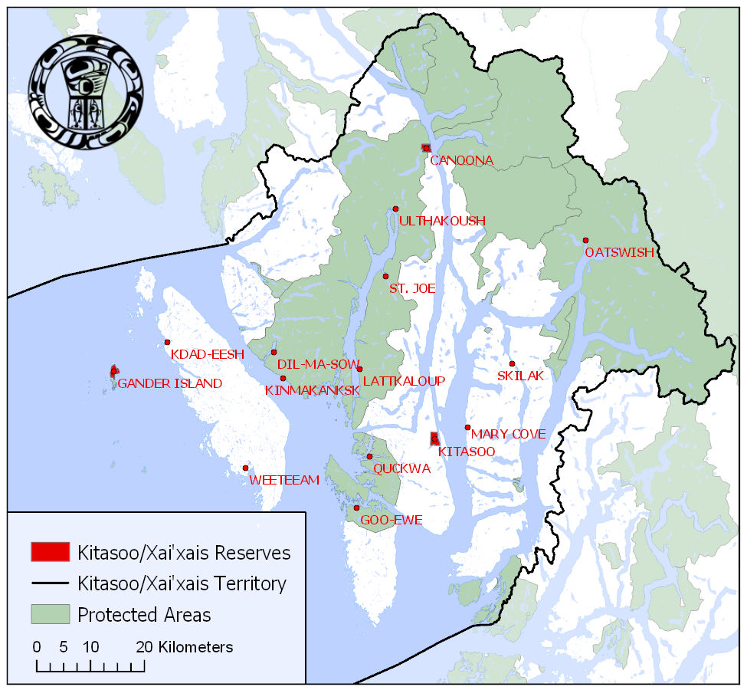
SCHEDULE A
Kitasoo/Xai’Xais Territory

